Network Task

1.Get me the IP address of a particular domain (guvi.in). How do I find my CPU/memory usage of my server?. Test the connectivity between 2 nodes?

To fetch Ip Address :

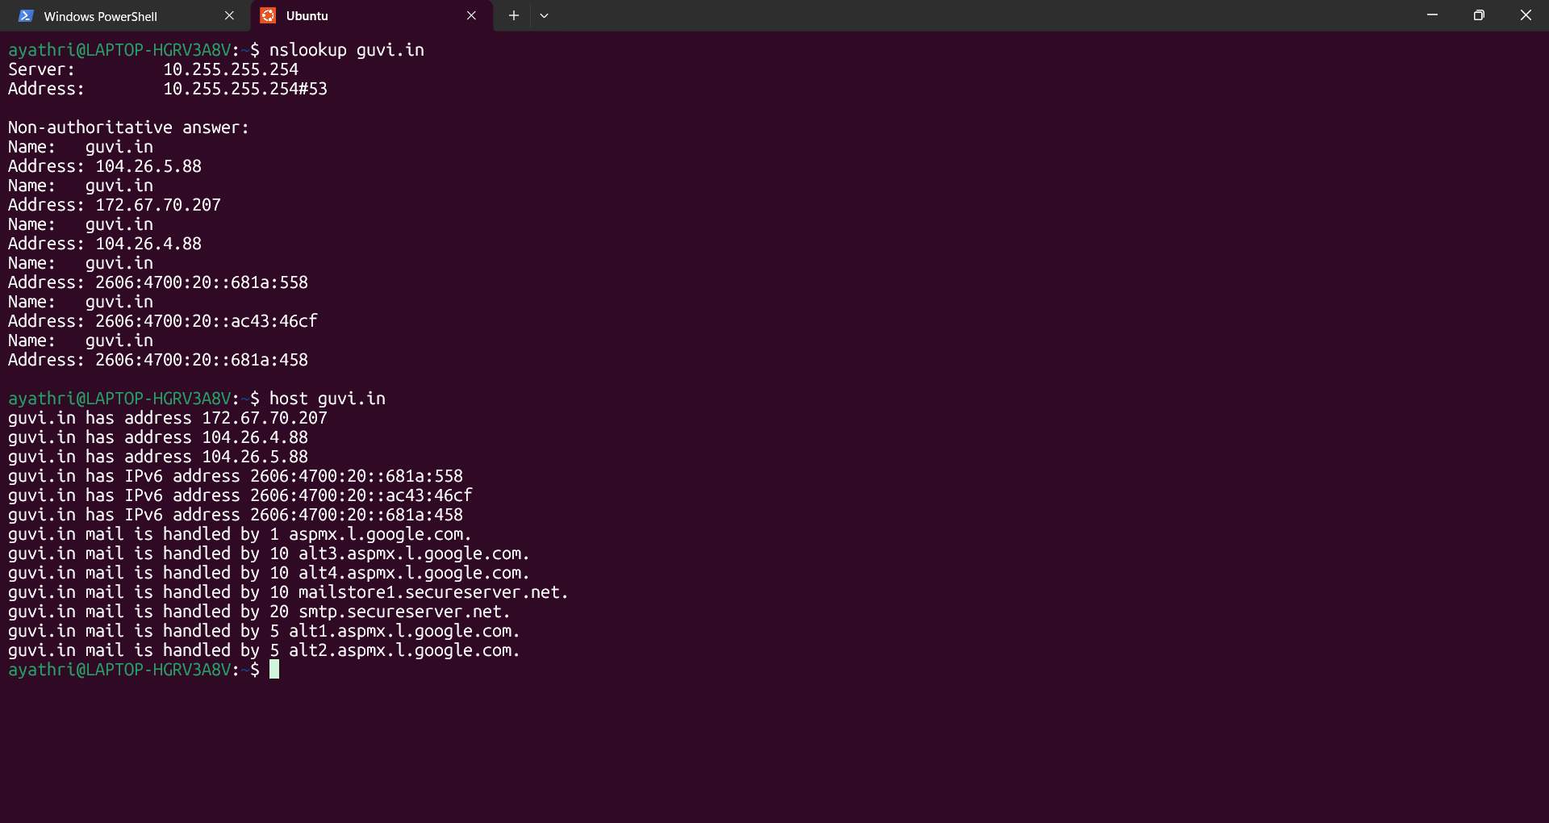

To see CPU Utilization :

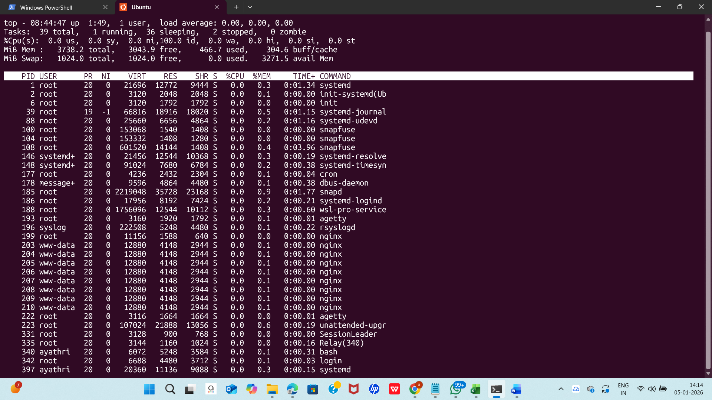

To check Connectivity between two nodes : ( used ping and traceroute methods to check )

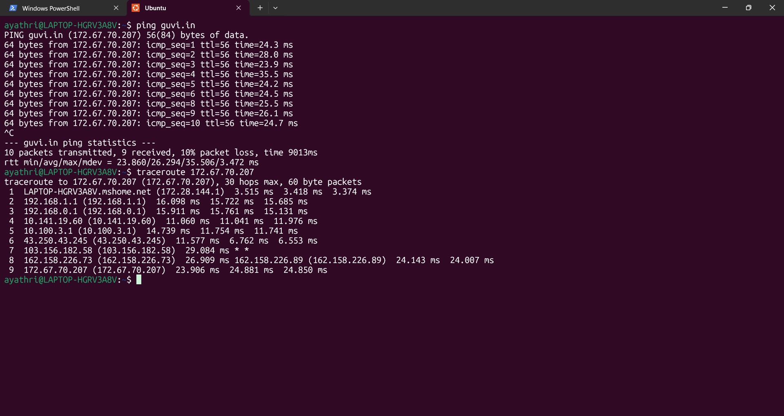

2.I have deployed an application in guvi.com:9000, and logs show my app is running, but I’m unable to view the page. Check whether my port is open or not ?

To check port is opened or not : telnet
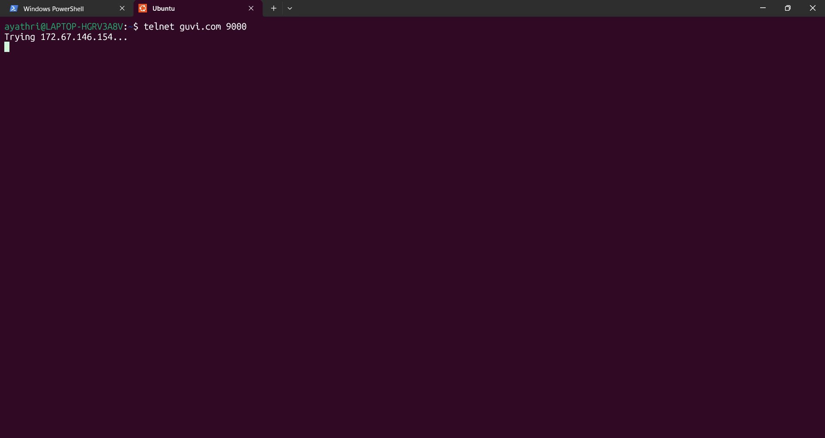

Trying for long time hence the port 9000 is not opened.

Alternate method to check using curl command :

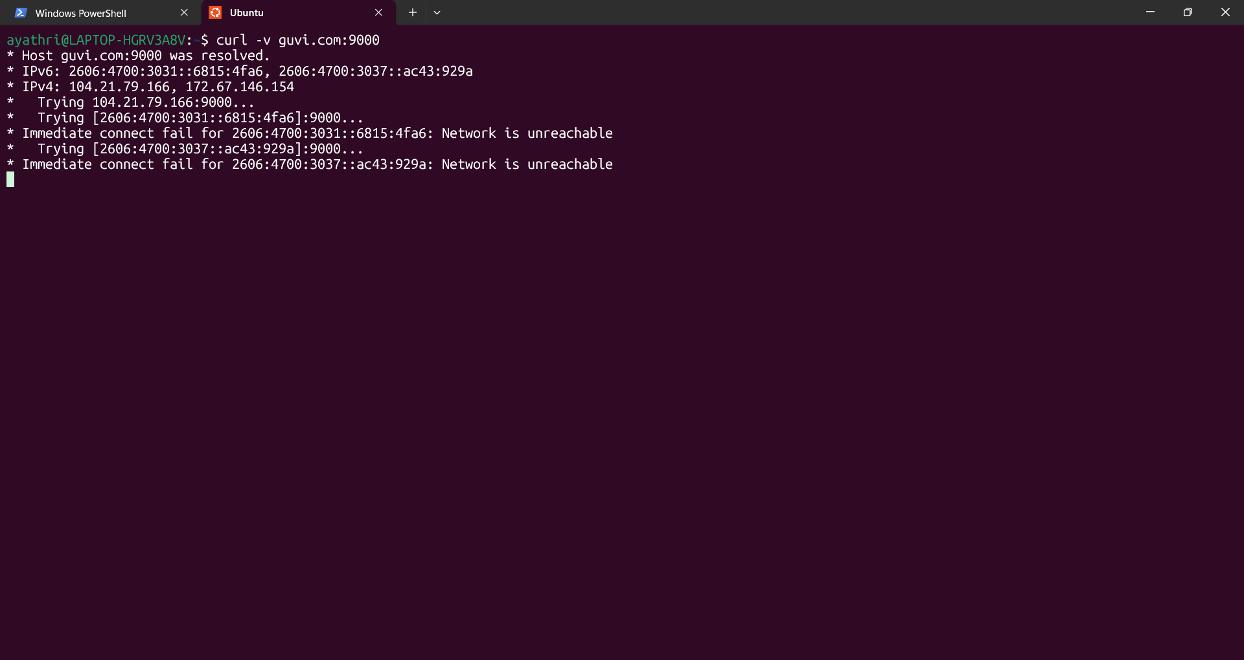

Port 9000 is not opened.

